Over 30 Virtual Field Trips with Links
(Click on colored text for links. Safe Travels!)
San Diego Zoo |  | The San Diego Zoo has a website just for kids with amazing videos, activities, and games. Enjoy the tour!
Yellowstone National Park Virtual Field Trip |  | Mud Volcano, Mammoth Hot Springs, and so much more.  Tour Yellowstone National Park!
MARS!!! | 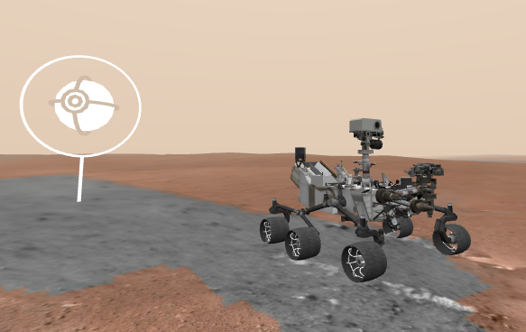 | Explore the surface of Mars on the Curiosity Rover.  They are updating from WEBVR to WEBXR now, but 360 Mode offers a digital view!
Animal Cameras | 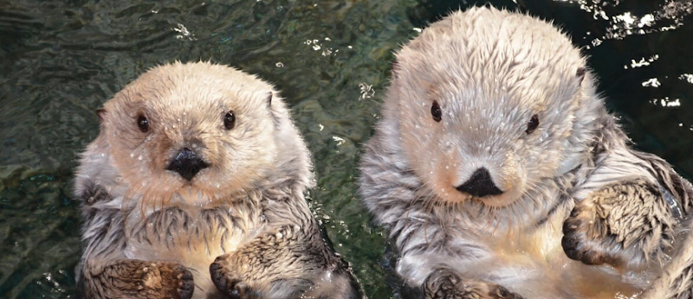 | Live Cams at the San Diego Zoo  Monterey Bay Aquarium live cams  Panda Cam at Zoo Atlanta  6 Animal Cams at Houston Zoo  Georgia Aquarium has Jellyfish, Beluga Whales, and more
Virtual Farm  Tour |  | This Canadian site FarmFood 360 offers  11 Virtual Tours of farms from minks, pigs, and cows, to apples and eggs.
U.S. Space and Rocket Museum in Huntsville, AL | 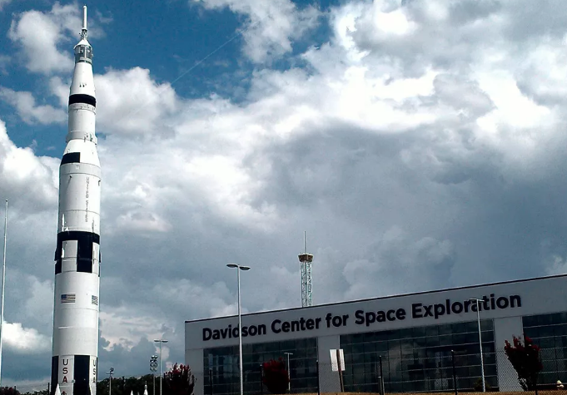 | See the Saturn 5 Rocket on YouTube and more on this tour thanks to a real father/son outing.
Discovery Education Virtual Field Trips |  | A few of the field trip topics include  Polar Bears and the Tundra  Social Emotional Skills  STEM  manufacturing
The Louvre |  | Travel to Paris, France to see amazing works of art at The Louvre with this virtual field trip.
The Great Wall of China |  | This Virtual Tour of the Great Wall of China is beautiful and makes history come to life.
Boston Children’s Museum |  | Walk through the Boston Children’s Museum thanks to Google Maps!  This virtual tour allows kids to explore 3 floors of fun.
Have fun learning at home!
-Mrs. Fahrney

